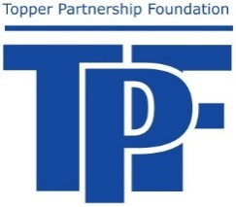
Topper Partnership Foundation
School District of Glenwood City
850 Maple Street
Glenwood City, WI 54013

DONOR CONTRIBUTION & ASSIGNMENT FORM

Donor Name: Phone:

Address:

I would like to make a donation to the Topper Partnership Foundation in the amount of $

I would like my donation allocated as follows:
Endowment Fund $ %
Student Scholarship Fund $ %
Designated scholarship
Non-designated/any scholarship (Name of designated scholarship)
TPP Ideas Fund $ %
Co-Curricular Fund $ %
General Fund $ %

TOTAL $ %

Endowment Fund
The TPF Endowment Fund supports the ongoing viability of all programs of the TPF.

Scholarship Fund
The TPF Scholarship Fund supports excellence in instruction and enrichment for students. Scholarships may be awarded by competitive process.

TPF Ideas Fund
The TPF Fund supports excellence in the classroom, excellence in instruction and recognition of excellence. Grants are awarded to teachers who have developed programs that incorporate new ideas and present unique learning opportunities to enrich classroom experiences for learners.

Co-Curricular Fund
The TPF Co-Curricular Fund supports the strong co-curricular activities in the SDGC.

General Fund
Operational expenses in support of the TPF.

(optional)

My donation is being made:

In Honor of In Memory of

I would like my donation to remain anonymous (initial)

Donor Signature: Date:

Donation received by (TPF member or District staff member):

